HealthCare Management System

Name
Institution of Affiliation
Instructor
Date

HealthCare Management System
Section 1: Interaction Diagrams
In order to capture the dynamic behavior of the system, interaction diagrams were used.
The sequence diagrams and the UML interaction diagrams for the proposed system are contained in Fig 1, Fig 2 and Fig 3 below. The design principles that were used for diagnosing problems were as follows;
- Sequence diagrams
The sequence diagram was used to capture how information is transmitted throughout the system. More specifically, it captures the order of messages as it flows from one part of the system to the other. The lab test sequence diagram is shown in figure 1 below.

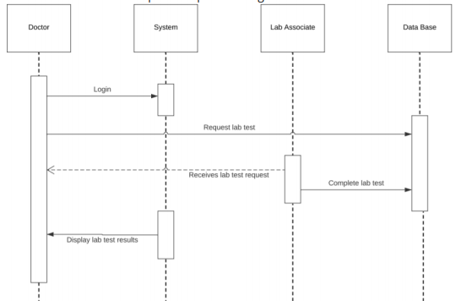
Fig 1. Lab test sequence diagram

Fig 2. Delete sequence diagram
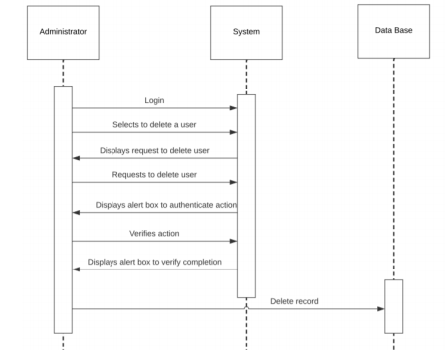

Section 2: Class Diagrams and Interface Specifications
- Class Diagram
A domain model is represented by several class diagrams. The purpose of the domain model diagram, shown in figure 21, is to display and demonstrate the structure of the hospital and the relationships with the associates (staff). Every associate (staff) has a unique ID number and personal credentials to access the system. Every associate is part of a department. Departments are divisions of the hospital shared by patients who need a similar classification of care. There are specific doctors assigned to each department in the hospital. Every patient is assigned a unique ID number when they are registered for the first time in the system
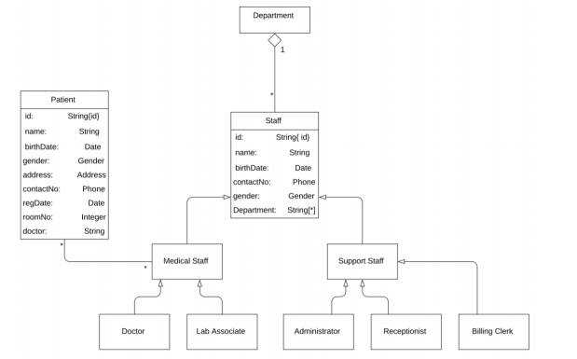
- Data Types and Operation Signatures
- Patient
Attributes
-String id
-String name
-Date birthDate
-String gender
-String address
-String phone number
-Date regDate
-Int roomNo.
-String doctor
Operations
+regDate ()- registers date of patient admission or visit
+savedata():- stores the data in database and then commit.
Staff
-String id
-String name
-Date birthDate
-String gender
-String phone number
-Date regDate
-String Department
Operations
+savedata():- stores the data in database and then commit.

- Traceability Matrix
The domain model was designed from the existing use case model. The domain model should be view as an interface between the planning phase and the design phase of the database development.
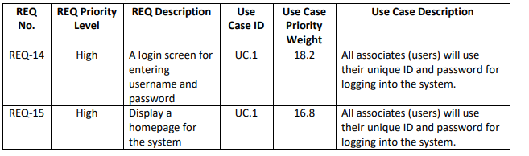

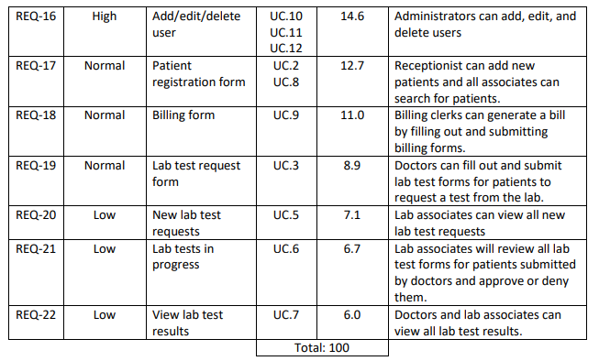
Section 3:
System Architecture and System Design
- Architectural Styles
According to Rechtin, and Maier (2010), an architectural style defines a family of systems used to determine the connectors or family of components that can be applied in instances of that given style together with a set of constraints. The components are what constitute the software. The constraints on the other hand define the specific system behavior. The frond design used the Model-View-Controller architecture. The data that will be used to run the system will be stored on a BHM server. Generally, the system will use client/server architecture. The front and back ends will use component-based architectural style
- Identifying Subsystems Draw and describe UML package diagram of subsystems of your system.

The system will be made up of a front-end GUI who role is to interface with the end-user to enable for interaction with the system and viewing of the data from the system.
The frond end server on the other hand retrieves data from the database and avails it to the user through the front end GUI. The front-end server also store new data in the database. The database is tasked with holding persistent information on patients and staff. The backend on the other hand provides feedback to doctors and administrators and is also used for updating user information. It can also be used to access data histories.

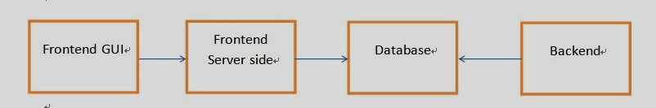

- Mapping Subsystems to Hardware Will your system run on multiple compue
The server will be hosted on a single machine. However, the entire system will be hosted across a distributed system. The system has two elaborate sections-the front end and the back end. The database will reside on the server. The front end will then be subdivided into two separate elements the graphical user interface (GUI) and the server side section.
- Persistent Data Storage
MySQL database will be sued to implement persistent data storage.
e. Network Protocol
The system’s server runs on a localhost that has a MySQL database server as well as an Apache web server. The client is made up of JSP, HTML and will interact with the end-user using the two services. The external connection to the server uses HTTP requests via Port 80. The front end users JSP’s internal server while the backend uses JDBC driver for the sake of connecting to the system’s MySQL database.
f. Global Control Flow
The system is event-driven and it involves user inputs that prompts it to action. All user interactions are needed in the front end and they involve actions like logging in and data inputs. All login activities must come from without the system.
g. Hardware Requirements
The system has server-side and client-side hardware requirements.
- Server-side
The server-side are based on the latest Intel Zeon E., processors. The system will also be equipped with a WLAN connection and a network card. These requirements will be necessary for server maintenance and administration.
- Client-side
The client side will be based on the need for system with GUI displays. The CPU’s that will be included include various vender provided CPUs, Graphic Cards (640 × 480 pixels minimum resolutions), RAMs, keyboards and mouse. Ethernet and wireless ports are also a requirement. Other requirements include 10 Gbyte hard disk space; and minimum network bandwidth 128 Kbps.
Section 4: Algorithms and Data Structures
- Algorithms
The algorithms that will be used in the design of the system will be based on secure and easy to process structures.
- Data Structure
The system will employ a liner data structure in order to allow for the hierarchical storage of information in a relational database.
Section 5: User Interface Design and Implementation
The user interface and design will be implemented using the requirements below;
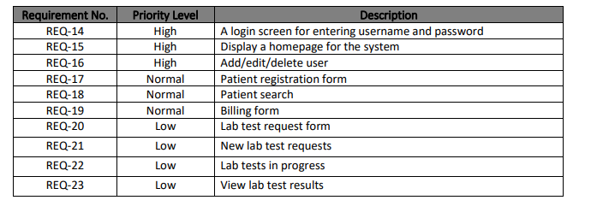
UC1. For use case number one, the user will log into the system by entering their username (which is their ID number) and password into the blank fields, which is indicated by the red arrows in figure 1. After the user selects the login button, the system will present the homepage, as shown in figure below.
Navigation path:
1. Click on the username field
2. Then, type in username
3. Click on the password field
4. Then, type in password
5. Then, select the login button

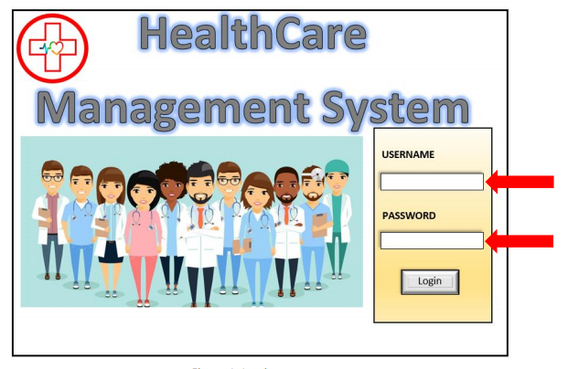
Section 6: Design of Tests •
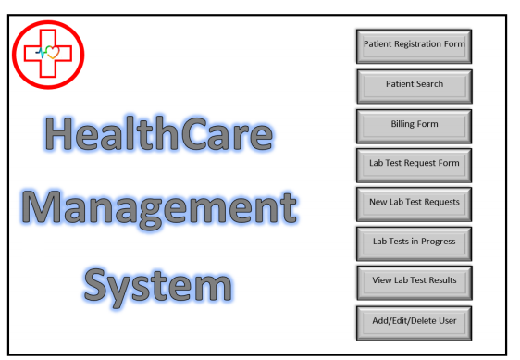
UC.2 For use case number two, the user will click on "Patient Search" from the homepage (figure 2). The system will present the user with the patient search page. The user will enter the patient's ID number (indicated by a red arrow in figure 3), name (indicated by a red arrow in figure 3), or date of birth (indicated by a red arrow in figure 3). Once the user has entered the information in at least one of the fields, they will select the search button. The system will display all results in the results window, which is indicated by a blue arrow in figure 4. The user will select which patient profile is needed, then the system will display all the patient's information, as shown in figure 5. From here, the user can edit and save any information if needed.
Navigation path:
1. Log in
2. Click on patient search from homepage
3. Then, enter patients D.O.B
4. Click the search button
5. Select patient from results window

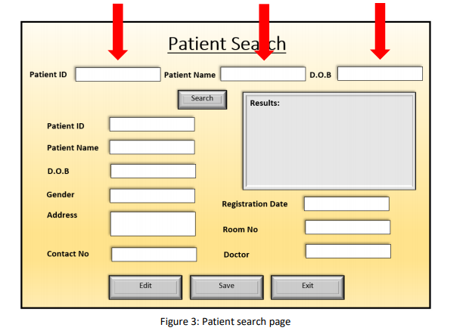
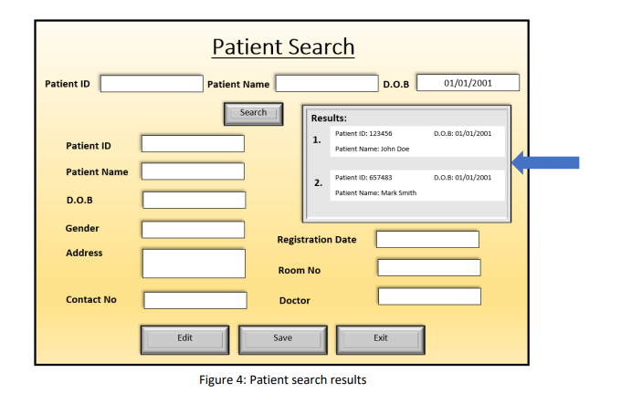
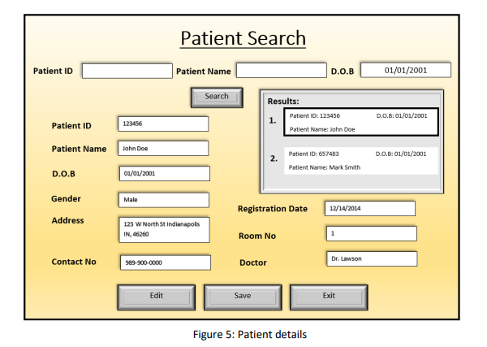
UC.3 For use case number three, the user will log in and click on "Lab Test Request Form" from the homepage. Doctors are the only users authorized to submit lab test requests. The system will present the user with the page for lab test request forms (figure 6). The user will enter all information that is displayed on the form and select submit (figure 7). If the user doesn't want to submit the form right away, they can select the save button instead. The patient's name will appear in the incomplete/saved lab test request form window so they can go back and submit the request later, indicated by a blue arrow in figure 8.
Navigation Path:
1. Log in
2. Click on lab test request form from homepage
3. Enter in all information for the form
4. Then, click on the submit button
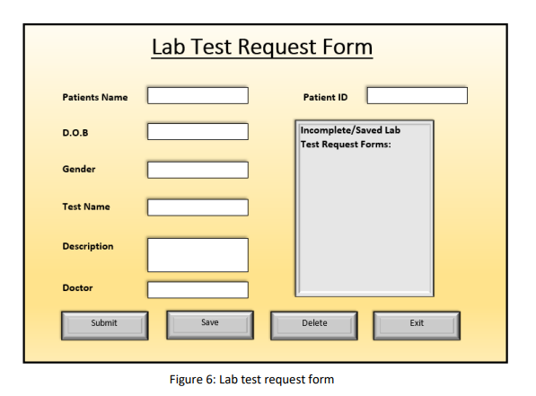

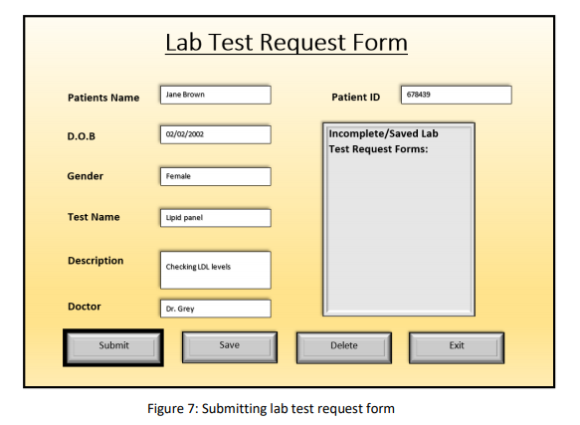
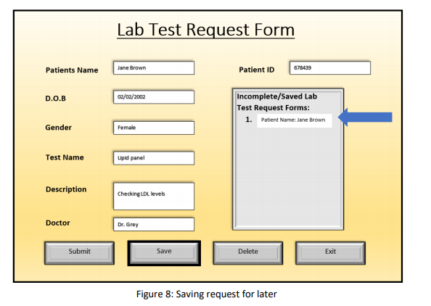
UC.4 and 5 -For use case number four and five, the user will log in and click on "Lab Test Requests" from the homepage. Lab associates are the only users authorized to access the lab test requests page. The system will present the user with the lab test requests page that displays all the new lab test requests in the window, as indicated by a blue arrow in figure 9. If needed, the user can search for a patient's lab test request by entering the patient's ID number in the blank field, as indicated by the red arrow in figure 9. The user can approve, deny, edit, or delete a lab test request.
Navigation path:
1. Log in
2. Click on lab test requests from the homepage
3. Click on the first new lab test request shown in the window
4. Approve or deny the request
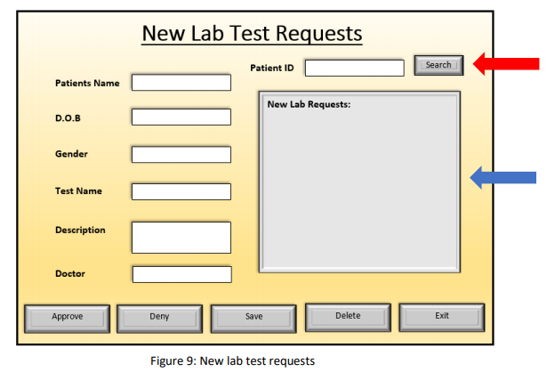
UC.6 For use case number six, the user will log in and click on “Lab Tests in Progress" from the homepage. Lab associates are the only users authorized to access the lab test progress page. The system will present the user with the lab test progress page that displays all the lab tests that are currently in progress in the window, as indicated by the blue arrow in figure 10. If needed, the user can search for a patient's lab test by entering the patient's ID number in the blank field, as indicated by the red arrow in figure 10. Once the lab associate has finished a lab test, they will click on the request from the window (indicated by the blue arrow) and select complete, as depicted in figure 11.
Navigation path:
1. Log in
2. Click on lab tests in progress from the homepage
3. Select the request from the window
4. Click on complete

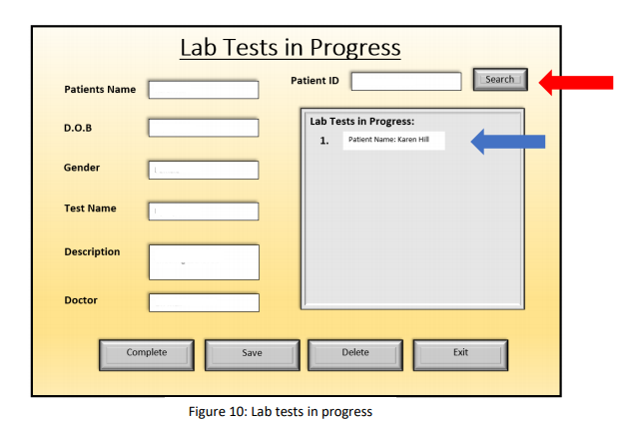
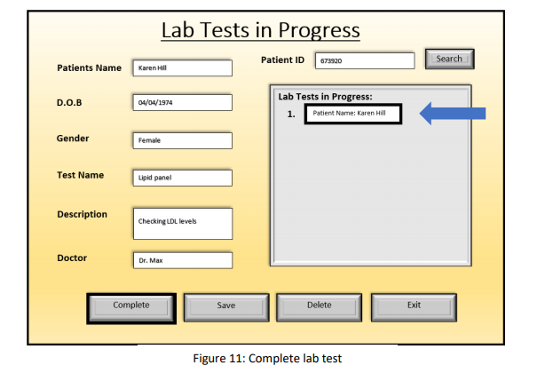
UC.7 For use case number seven, the user will log in and click on "Lab Test Results" from the homepage. Lab associates and doctors are the only users authorized to access the lab test results. The system will present the user with the lab test results page that displays all the lab tests that have been completed in the window indicated by the blue arrow in figure 12. If needed, the user can search for a patient's lab test by entering the patient's ID number in the blank field, as indicated by the red arrow in figure 12. The user will click on the patient's name in the window to see their test results, as shown in figure 13. Navigation path:
1. Log in
2. Click on lab test results from the homepage
3. Select the patients name from the window
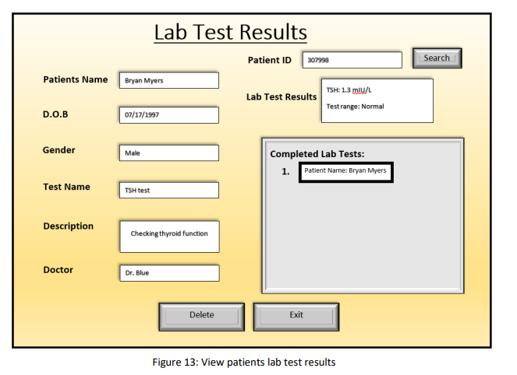
UC.8
For use case number eight, the user will log in and click on "Patient Registration Form" from the homepage. Receptionists are the only users authorized to access the patient registration form. The system will present the user with the patient registration form page. The receptionists will enter all patient information into the blank fields and click on add. If needed, the user can click on save instead of adding, and the system will save the patient info and display it in the incomplete/saved patients registration form window as indicated by the blue button in figure 14.
Navigation path:
1. Log in
2. Click on patient registration form
3. Enter in patient information
4. Click add
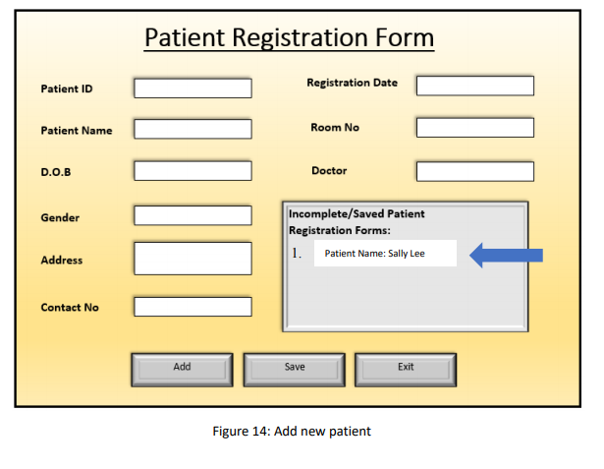
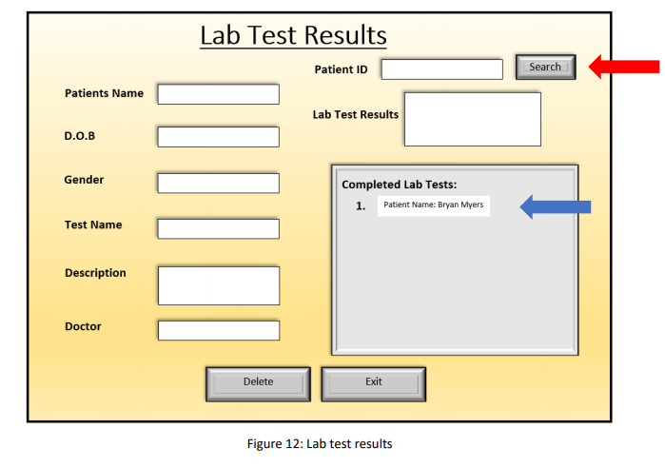
UC.9
For use case number nine, the user will log in and click on "Billing Form" from the homepage. Billing Clerks are the only users authorized to access billing forms. The system will present the user with the billing form, and they will enter all information into the blank fields, as shown in figure 15. The user will then click on the total button, and the system will present the total amount due, as shown in figure 16.
Navigation path:
1. Log in
2. Click on billing form
3. Fill in blank fields
4. Click on total
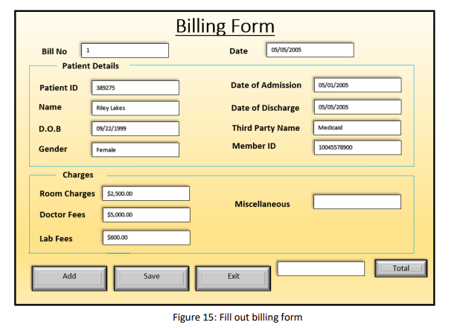
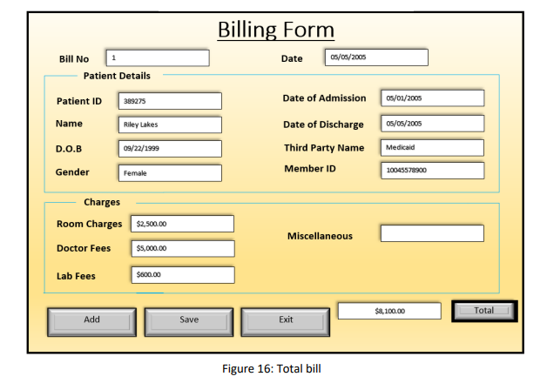
UC.10, 11, 12
For case numbers ten, eleven, and twelve, the user will log in and click on "Add/Edit/Delete User" from the homepage. Administrators are the only users authorized to access this page. The system will present the user with the page. The user will select which action they want to do, as indicated by the blue arrow in figure 17. If the user selects add user, they will then enter in all information at the bottom of the page (except for ID), select add, then they system will generate a unique ID number (indicated by a green arrow in figure 17) for the user (as shown in figure 17). If the user selects edit user, they will enter in the associate's (user) ID number and click search, as indicated by the red arrow in figure 19. After the user selects the search button, the associate's information will be displayed, as shown in figure 19. If the user wants to delete a user, they will select delete users, enter users ID as shown in figure 20. They will then enter the ID number (as indicated by the red arrow in figure 20), click on search, then click on delete as shown in figure 19
Navigation path:
1. Log in
2. Click on add/edit/delete user from homepage
3. Select which action is needed
4. Enter information into blank fields
5. Click on add if adding user
6. Or click on save if editing user
7. Or click on deleted if deleting user
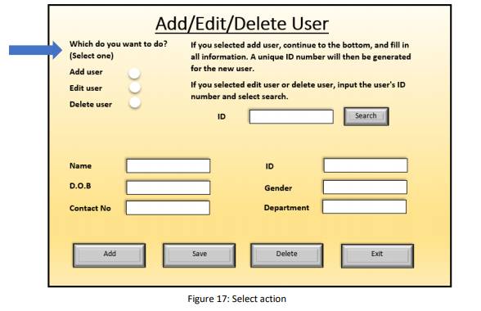
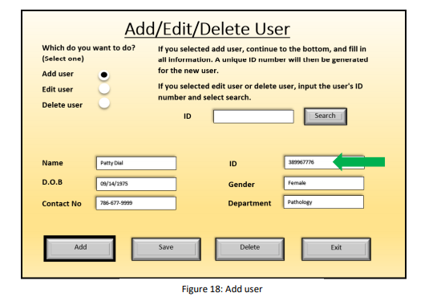
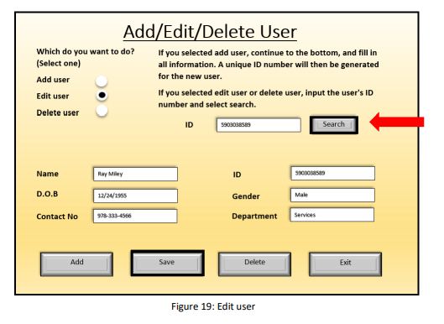
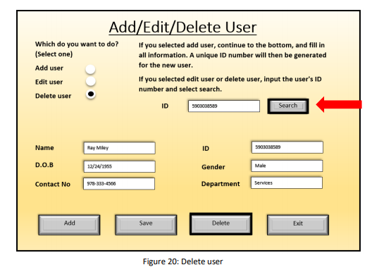
Section 7: Project Management and Plan of Work
a. Project Coordination and Progress Report
i. List use cases that have been implemented.
All usecases from UC1 to UC12
- What is already functional, what is currently being tackled?
The entire project is already functional. What remains is project handover and deployment
- List and describe other related project management activities.
Project deployment and maintenance
b. Plan of Work
i. List the project milestones and dates by which you plan to accomplish them using Gantt chart
- Software and hardware acquisition- 4 months
- Project design- in 6 months
- Project testing- 11 months
- Project handover-in 12 months

References
Rechtin, E., & Maier, M. W. (2010). The art of systems architecting. CRC press.

